Unit 2 Notes
Electromagnetic Radiation

Electromagnetic Radiation - ___________________ being transmitted from one place to another by _________________

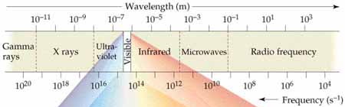

_______________________ and ______________________ differentiate the different forms of EMR

Wavelength – The _______________________ between two consecutive wave _______________

Frequency – How many wave peaks pass a certain point per given period of time

Speed- All light travels with the speed of ____________________________

Scientists have found that light behaves as both a _____________ and a ___________________

Photons – a stream of tiny packets of _______________________

Emission of Energy by atoms-

What was happening during our flame test lab causing us to see different colors?

Why do we see certain colors in spectroscopes for different gaseous elements?

Wavelength and frequency calculations:

Formula:

c= _______________ of light (always ________________________)

λ = __________________________, units:

v=___________________________, units:

Examples:

What is the wavelength of a wave with a frequency of 4.38 x 10¹⁴ Hz

What is the frequency of a wave with a wavelength of 3.98 x 10⁻⁶ m

What is the wavelength of a wave with a frequency of 9.87 x 10¹³ Hz

What is the frequency of a wave with a wavelength of 5.22 x 10⁻⁷ m

