Heat of Fusion and Heat of Vaporization Worksheet

q=Hm H_{f} for water =334 J/g H_{v}= 2260 J/g

1. How much energy is absorbed when 8.97 grams of solid water is melted?

2. How much energy is released when 12.3 grams of water is frozen?

3. How much energy is released when 24 grams of water vapor condenses into a liquid?

4. How much energy is absorbed when 73.4 grams of water freezes.

5. What energy change is associated with the vaporization of 72 grams of water?

6. What energy change is associated with the condensation of 10.3 grams of water?

7.
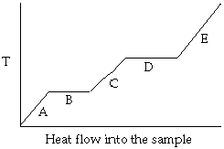

- Identify the point on the above heating curve where the sample would exist in both the liquid and gaseous state?

- Identify the point on the graph which corresponds to the heat of fusion

- Identify the point that corresponds to the melting point of the compound being heated

- Identify the point where the compound is in the solid state.

- If I move from point E to C on the heating curve would the change in state be exothermic or endothermic?

