Unit 7 Test Review

Vocabulary:
- Activation energy: ___________________________________________________________________

- Endothermic: ________________________________________________________________________

- Energy: _______________________________________________________________________________

- Exothermic: __________________________________________________________________________

- Heat: __________________________________________________________________________________

- Heat of fusion: _______________________________________________________________________

- Heat of vaporization: ________________________________________________________________

- Joule: _________________________________________________________________________________

- Kinetic Energy: ______________________________________________________________________

- Potential Energy: ____________________________________________________________________

- Temperature: ________________________________________________________________________

Identify the following as kinetic or potential energy:
- ____________ A ball rolling down a hill
- ____________ A stretched rubber band
- ____________ A candle burning
- ____________ A loaf of bread
- ____________ Oil in a lawnmower

- Compare/Contrast:
 | Endothermic | Exothermic
Energy is…(released/absorbed)
Surroundings feel….(hot/cold)
ΔH is..(positive/negative)
Energy is a…(reactant/product)

Identify the following as endothermic or exothermic:
- ______________ Iron melting
- ______________ Bread baking
- ______________ Respiration (O₂ + C₆H₁₂O₆ CO₂ + H₂O + energy)
- ______________ Water vapor condensing
- ______________ Sweat evaporating from your skin

Conversions:
K = [°C] + 273 1 cal = 4.184 J 1000 J =1kJ 1000 cal= 1kcal

- 35°C = ___________K
- 305 K = __________°C
- -145°C = __________ K
- 6.54 kJ = __________ cal
- 74536 J = __________ kcal
- 945 cal = __________ J

- Describe the flow of heat when you touch a system that feels COLD:

- Describe the flow of heat when you touch a system and it feels HOT:

- In an exothermic reaction, the products have (MORE) (LESS) energy than the reactants.

- When a hot metal is added to water, how does the amount of energy lost by the metal compare to the amount of energy gained by the water?

- Using the diagram below, identify the line segment that corresponds to the following:
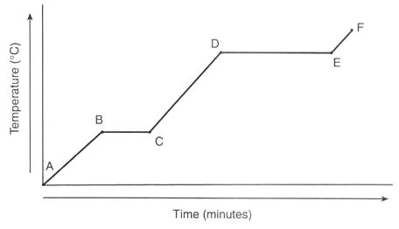
  - Solid _____________
  - Liquid _____________
  - Gas _____________
  - Melting _____________
  - Vaporizing _____________
  - Freezing _____________
  - Condensing _____________

- What is the temperature at line segment:
  - B-C ______________
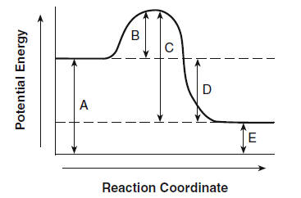
  - D-E ______________

- In the diagram to the right, identify:

F
- Reactants: ____________
- Products: __________

G
- Activation energy: __________
- ΔH: __________
- Endothermic / Exothermic?

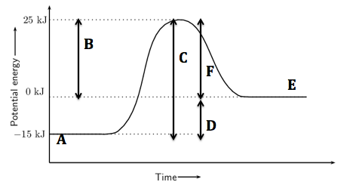
- In the diagram to the right, identify the:
- Reactants: ____________
- Products: __________
- Activation energy: __________
- ΔH: __________
- Endothermic / Exothermic?

Problems:
Equations | Specific Heat Capacities (J/g °C) | Energy Constants
q=mcΔT | Gold = 0.129 | Specific heat (c) of water = 4.184 J/g °C
q=Hm | Silver = 0.236 | Heat of fusion (H_{f}) of water = 334 J/g
 | Iron = 0.448 | Heat of vaporization (H_{v}) of water = 2260 J/g
 | Zinc = 0.388
 | Tin = 0.220

- How much energy must be absorbed by 20.0 g of silver to increase its temperature from 283.0 °C to 303.0 °C?

- A 45 gram bar of iron is cooled from 195°C to 22°C, calculate the amount of energy released from the iron?

- What will be the final temperature when a 150.0 g piece of Zinc absorbs 3424 joules of heat? The initial temperature of the Zinc is 22.0°C.

- Calculate the amount of energy required to melt 83.6 grams of ice at 0 ̊C.

- How much energy is released when 235 grams of water is boiled into a gas at 100 ̊C?

- An unknown metal with a mass of 150 grams is heated from 38.4 ̊C to 70.4 ̊C when 619.2 J of energy is added. What is the specific heat capacity of the substance? Use the table above to identify the substance.

- A piece of copper with a mass of 256.8 grams was heated to 135.79 ̊C and quickly immersed in 100 grams of water that was at a temperature of 22 ̊C. The water and copper came to a final temperature of 43.79 ̊C. What is the specific heat of copper?

- 839.5 J of energy is used to heat an unknown sample of metal with a mass of 84.3g from 22.0 ̊C to 44.2.0 ̊C. Calculate the specific heat and identify the unknown substance using the table above.

- A 29.4 gram sample of aluminum is heated to 135.0 ̊C and dropped into 48.34 grams of water, initially at 22.0 ̊C. The final temperature of both the water and the aluminum is 35.2 ̊C. Calculate the specific heat capacity of aluminum.

- A 94.3 gram sample of water at 32° C absorbs 349 J of heat. What is the final temperature of the water sample?

- How many kilojoules of energy is released when 33.4 grams of water vapor condenses?

- 10.0 g of a fuel are burned under a calorimeter containing 200.0 g of H₂O. The temperature of the water increases from 15.0 °C to 55.0 °C. Calculate the total heat produced (in joules).

- If it takes 41.72 joules to heat a piece of gold weighing 18.69 g from 10.0 °C to 27.0 °C, what is the specific heat of the gold?

- A 23.9g sample of a metal was heated to 61.78 degrees C. When the metal was placed in a constant-pressure calorimeter containing 30.0g of water, the temperature of the water rose from 24.52 degrees C to 29.66 degrees C. Calculate the specific heat of the metal.

- What will be the final temperature when 24.3 kilojoules of energy is absorbed by 200 gram of water at an initial temperature of 22°C.

