Unit 8 Review
1. What are the two requirements of the collision theory that must be met for a chemical reaction to occur?
1.

2.

2.What are four ways to increase the rate of reaction? Discuss each in terms of the collision theory.
1.

2.

3.

4.

3. What are three ways to decrease the rate of reaction? Discuss each in terms of the collision theory.
1.

2.

3.

4.What is the role of a catalyst in a chemical reaction? How does a catalyst affect reaction rate? How does a catalyst affect a system at equilibrium?

5.List three stresses that can be added to a system to make it shift left or right
1.

2.

3.

6. Explain which direction the equilibrium will shift in the following equation when the following stresses are added to the system
CO_{(g)} + H₂O_{(g)} CO_{2(g)} + H_{2(g)}
1. Increase pressure 2. Remove H₂O

3. Add CO 4. Add a catalyst

5. Increase Temperature 6. Remove H₂
7.The following is an endothermic reaction. Explain which direction the equilibrium will shift in the following equation when the following stresses are added to the system
POCl_{3 (g)} <===> POCl _{(g)} + Cl_{2(g)}

1.Decrease Pressure 2. Add POCl₃

3.Remove heat 4. Add Cl₂

5. Remove POCl 6. Cool the container

8. The following is an exothermic reaction. Explain how the concentration of SO₃ when the following stresses are added to the system
SO_{2 (g)} + NO_{2 (g)} <===> SO_{3 (g)} + NO_{(l)}

1. Adding NO 2. Decreasing pressure

3. Remove NO₂ 4. Add heat
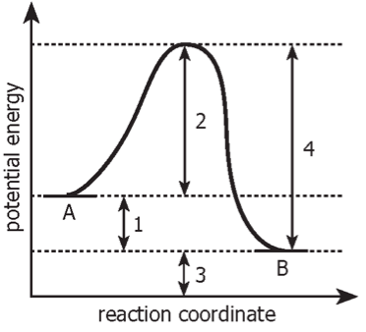

Identify the following in the energy diagram to the left:

Activation Energy:

ΔH:

Is the energy diagram endothermic or exothermic?

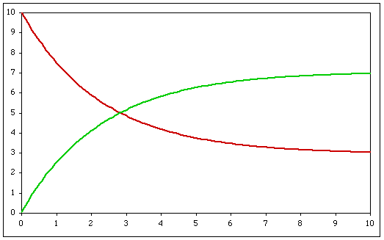
C In the following
O concentration vs time
N graph identify the point
C where both the reactants
E and products reach
N equilibrium?
T
R
A
T
I
O
N TIME (s)

