Unit 9 Notes
Acids and Bases

Acid – A substance that produces _________________________ ions (H⁺) in solution, a proton donor.

Properties of Acids: _________ taste, ________ pH(<7), turns litmus paper __________

Base – A substance that produces __________________________ ions (OH⁻) in solution, a proton acceptor.

Properties of Bases: ______________ taste, feel ________________, high _____(>7), turn litmus paper blue

Conjugate acid – the substance formed when a ______________________ is added to a base

Conjugate base – the remaining substance when a ___________________ is lost from an acid

Example: HA_{(aq)} + H₂O_{(l)} H₃O⁺_{(aq)} + A⁻_{(aq)}
Acid Base Conjugate Conjugate
Acid Base

H₃O⁺ is also known as the _______________________________ ion

pH - scale used to measure the _____________________ of an acid. Based on the ________ or the concentration of Hydrogen ions. pH scale ranges from 0-14

pOH – scale used to measure the ____________________ of a base. Based on the _________ or the concentration of the Hydroxide ions. pOH scale ranges from 0-14

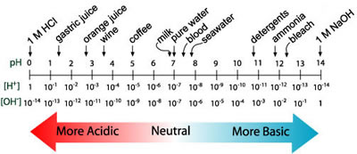

Formulas

K_{w} formula: [H⁺][OH⁻] = 1.0 x 10⁻¹⁴ pH and pOH formula: pH + pOH =14

pH formula: pH = -log[H⁺] pOH formula: pOH = -log[OH⁻]

[H⁺] formula: [H⁺] = 10^{-pH} [OH⁻] = 10^{-pOH}

Examples:

Calculate the pH value and identify the solution as acidic, basic, or neutral:

a. A solution in which [H⁺] = 1.0 x 10⁻⁹ M b. a solution in which [OH⁻] = 1.0 x 10⁻⁶ M

Calculate the pH and pOH of the following solutions:

a. 1.0 x 10⁻³ M OH⁻ b. 1.0 M H⁺

The pH of blood is about 7.4 what is the pOH and the [H⁺] of human blood?

The pOH of water is 6.59 in a fish tank. What is the [OH⁻] and the[H⁺] of the water?

