Unit 9 Notes
Neutralization and Titration

Neutralization reaction – An ___________________________ reaction, results in a neutral solutions (pH = 7)

Titration – process used during a lab during a _______________________________ reaction. Uses a solution with a known concentration to calculate the unknown concentration of another solution.

Equivalence point – point at which ____________________, also the point where the titration process is finished.
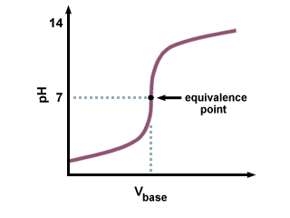
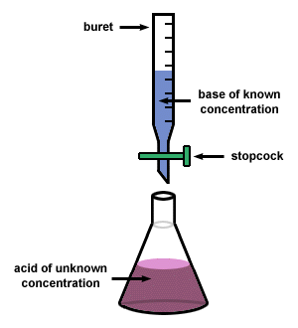

Buffered Solution – A solution that ________________ change in pH when either an acid or base is added.

Neutralization/Titration calculations:

Formula is the same for dilutions: M₁V₁ =M₂V₂

Examples:

Determine the volume of a 0.100M NaOH needed to titrate 50.0 mL of 0.200M HNO₃:

Calculate the concentration of 50.0 mL of HCl if it takes 75.0 mL of 0.150 M KOH to reach the equivalence point:

