Unit 7 Notes
Endothermic and Exothermic

In order to consider the energy flow as _______________ of a chemical reaction we will look at two specific parts: the system and the surroundings

The ___________________________will be the area of focus, usually the reactants and products of a chemical reaction

The ________________________________________ are everything else in the universe other than the system

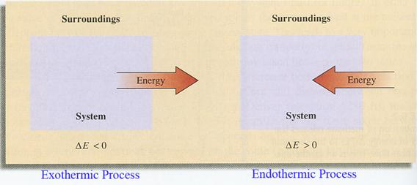

Exothermic Reactions:
- Energy as heat ________________________ into the _______________________________ by the system.

- Energy written as a ____________________ in a chemical equation. Example: A + BC AC + B + Heat

- The system feels _________________ to the observer.
- ΔH is _____________________, ΔH is energy that flows as heat
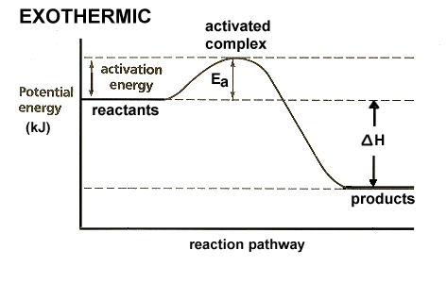
Energy Diagram*
Endothermic Reactions:
- Energy in the form of heat ________________________by the _______________________ from the surroundings

- Energy written as a ____________________________ in a chemical equation. Example: AB + CD + heat AD + CB

- System feels ______________________ to the observer

- ΔH is __________________________

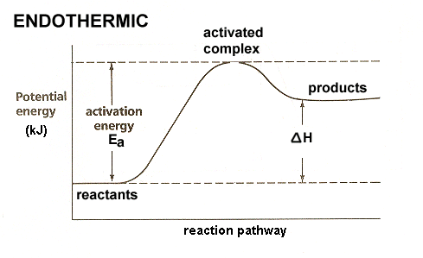
Energy Diagram*

