Unit 7 Notes
Specific Heat Capacity

-Specific heat capacity: the amount of ______________ in joules required to raise one

gram of a substance by one degree _________________________

-Symbol: ______

-Units: ____________

-Example: the specific heat capacity for water is 4.184 J/g°C

-Each compound/element has a ___________________specific heat capacity due to it’s composition
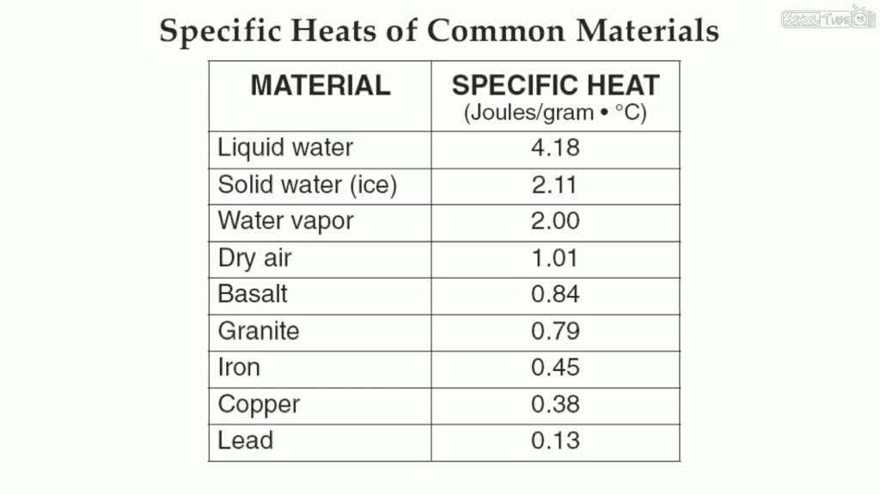
-The equation we will use involving heat capacity:

q = ___________ energy transferred in joules

m = mass of the substance in _____________

c = specific heat capacity in ______________

ΔT = change in ___________________________ in °C

*Examples on back*
-If the temperature of 7.0 g of water increases from 15°C to 65.5 °C how much heat was absorbed by the water?

-A sample of water gives off 982 J of energy when the temperature drops from 50°C to 24 °C. What is the mass of the water sample?

-A 43.9 g sample of iron has a specific heat capacity of 0.45 J/g°C. What was the final temperature of this sample if the heat absorbed was 82.3 kJ and the initial temperature was 47.3 °C?

-An unknown metal with a mass of 10.2 g was heated to 100.1 °C and dropped in 36.0 grams of 23.4 °C water. The water’s final temperature was 27.2°C. What is the specific heat capacity of the unknown metal?

