Unit 7 Notes
Heat of Fusion, Heat of Vaporization, and Heating Curves

There is a specific amount of _____________________ that is released every time an

element or compound changes _____________________________________________________.

Phase changes:

The following phase changes are always _____________________________:
- Condensation- Gas Liquid
- Freezing – Liquid Solid

The following phase changes are always ______________________________:
- Vaporization – Liquid Gas
- Melting – Solid Liquid

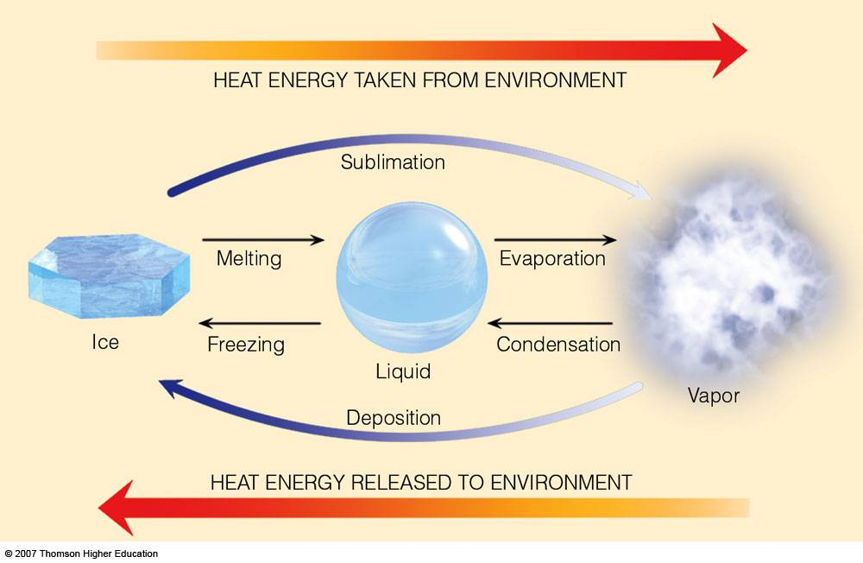
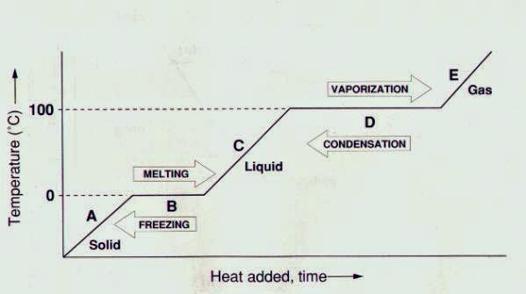

The Heat of Fusion is the energy change per gram associated with a ___________________ from the liquid state to the solid state or the solid state to the liquid state

Symbol: _________ Units: __________

Example: The Heat of Fusion for water is 334 J/g

Equation: ________________________ q= heat, H_{f}= heat of fusion, m=mass

For water the heat of fusion would be used at the melting point/freezing point or 0°C

H_{f} negative for freezing, positive for melting

The Heat of Vaporization is the ___________________________ in grams with a phase change from the liquid state to the gas state or from the gas state to the liquid state.

Symbol: _______ Units: _______

Example: The H_{v} for water is 2260 J/g

Equation: q=heat, H_{v}= heat of vaporization, m=mass

For water the heat of vaporization would be used at the condensation point/vaporization point or 100 °C

H_{v} negative for condensation, positive for vaporization

Examples:
Calculate the heat energy associated when 38.9 g of water freezes.

Calculate the heat energy when 49.2 g of water is boiled into its gaseous state.

